Account Summary Report
Account Summary Report is an at-a-glance report showing the performance of an entire AdWords account. Additionally, it sends an HTML-formatted daily email with current account statistics. An account manager could use a similar technique to email professionally-formatted reports directly to clients.
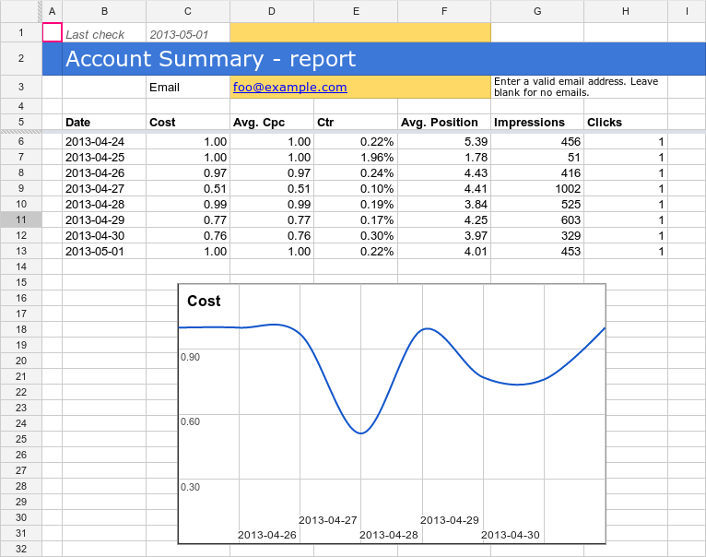

Scheduling
The script relies on previous day's statistics. Schedule it Daily, 3am or later to guarantee accuracy, since AdWords statistics may be up to 3 hours delayed.

How it works
The script fetches yesterday's statistics and updates the spreadsheet. The graphs are pre-configured to display the stats. If the email address is specified, the script sends out an HTML-formatted email.
Tip: if you set "Last check" date in the spreadsheet to a date in the past, the script will fill in the data between then and now. We recommend that you do not go back more than 90 days, as fetching statistics takes time.

Setup
- Setup a spreadsheet-based script with the source code below. Use Account Summary Report template spreadsheet
- Create a new script with the source code below.
- Don't forget to update SPREADSHEET_URL in code.
- Schedule the script Daily, 5am.
Setting up a spreadsheet-based script

Source code
var SPREADSHEET_URL = "[YOUR_URL]";
function main() {
var spreadsheet = SpreadsheetApp.openByUrl(SPREADSHEET_URL);
spreadsheet.getRangeByName("account_id_report").setValue(AdWordsApp.currentAccount().getCustomerId());
var yesterday = getYesterday();
var last_check = spreadsheet.getRangeByName("last_check").getValue();
// Checks every day from last day checked to yesterday inclusive. If there isn't a last date checked,
// checks yesterday.
var date;
if (last_check.length == 0) {
date = new Date(yesterday);
} else {
date = new Date(last_check);
date.setDate(date.getDate() + 1);
}
var rows = [];
while (date.getTime() <= yesterday.getTime()) {
var row = getReportRowForDate(date);
rows.push([new Date(date), row['Cost'], row['AverageCpc'], row['Ctr'], row['AveragePosition'], row['Impressions'], row['Clicks']]);
date.setDate(date.getDate() + 1);
}
if (rows.length > 0) {
var access = new SpreadsheetAccess(SPREADSHEET_URL, "Report");
var emptyRow = access.findEmptyRow(6, 2);
if (emptyRow < 0) {
access.addRows(rows.length);
emptyRow = access.findEmptyRow(6, 2);
}
access.writeRows(rows, emptyRow, 2);
var last_check = spreadsheet.getRangeByName("last_check").setValue(yesterday);
var email = spreadsheet.getRangeByName("email").getValue();
if (email) {
sendEmail(email);
}
}
}
function sendEmail(email) {
var day = getYesterday();
var yesterdayRow = getReportRowForDate(day);
day.setDate(day.getDate() - 1);
var twoDaysAgoRow = getReportRowForDate(day);
day.setDate(day.getDate() - 5);
var weekAgoRow = getReportRowForDate(day);
var html = [];
html.push(
"<html>",
"<body>",
"<table width=800 cellpadding=0 border=0 cellspacing=0>",
"<tr>",
"<td colspan=2 align=right>",
"<div style='font: italic normal 10pt Times New Roman, serif; margin: 0; color: #666; padding-right: 5px;'>Powered by AdWords Scripts</div>",
"</td>",
"</tr>",
"<tr bgcolor='#3c78d8'>",
"<td width=500>",
"<div style='font: normal 18pt verdana, sans-serif; padding: 3px 10px; color: white'>Account Summary report</div>",
"</td>",
"<td align=right>",
"<div style='font: normal 18pt verdana, sans-serif; padding: 3px 10px; color: white'>", AdWordsApp.currentAccount().getCustomerId(), "</h1>",
"</td>",
"</tr>",
"</table>",
"<table width=800 cellpadding=0 border=0 cellspacing=0>",
"<tr bgcolor='#ddd'>",
"<td></td>",
"<td style='font: 12pt verdana, sans-serif; padding: 5px 0px 5px 5px; background-color: #ddd; text-align: left'>Yesterday</td>",
"<td style='font: 12pt verdana, sans-serif; padding: 5px 0px 5px 5px; background-color: #ddd; text-align: left'>Two Days Ago</td>",
"<td style='font: 12pt verdana, sans-serif; padding: 5px 0px 5x 5px; background-color: #ddd; text-align: left'>A week ago</td>",
"</tr>",
emailRow('Cost', 'Cost', yesterdayRow, twoDaysAgoRow, weekAgoRow),
emailRow('Average Cpc', 'AverageCpc', yesterdayRow, twoDaysAgoRow, weekAgoRow),
emailRow('Ctr', 'Ctr', yesterdayRow, twoDaysAgoRow, weekAgoRow),
emailRow('Average Position', 'AveragePosition', yesterdayRow, twoDaysAgoRow, weekAgoRow),
emailRow('Impressions', 'Impressions', yesterdayRow, twoDaysAgoRow, weekAgoRow),
emailRow('Clicks', 'Clicks', yesterdayRow, twoDaysAgoRow, weekAgoRow),
"</table>",
"</body>",
"</html>");
MailApp.sendEmail(email, "AdWords Account " + AdWordsApp.currentAccount().getCustomerId() + " Summary Report", "", {htmlBody: html.join("\n")});
}
function emailRow(title, column, yesterdayRow, twoDaysAgoRow, weekAgoRow) {
return "<tr> \
<td style='padding: 5px 10px'>" + title + "</td> \
<td style='padding: 0px 10px'>" + yesterdayRow[column] + "</td> \
<td style='padding: 0px 10px'>" + twoDaysAgoRow[column] + formatChangeString(yesterdayRow[column], twoDaysAgoRow[column]) + "</td> \
<td style='padding: 0px 10px'>" + weekAgoRow[column] + formatChangeString(yesterdayRow[column], weekAgoRow[column]) + "</td> \
</tr>";
}
// returns noon in the timezone of the account
function getYesterday() {
var now = new Date(Utilities.formatDate(new Date(),
AdWordsApp.currentAccount().getTimeZone(), "MMM dd,yyyy HH:mm:ss"));
var yesterday = new Date(now.getTime() - 24 * 3600 * 1000);
yesterday.setHours(12);
return yesterday;
}
function getReportRowForDate(date) {
var accountDate = new Date(Utilities.formatDate(date,
AdWordsApp.currentAccount().getTimeZone(), "MMM dd,yyyy HH:mm:ss"));
var dateString = Utilities.formatDate(accountDate, "PST", "yyyyMMdd");
return getReportRowForDuring(dateString + "," + dateString);
}
function getReportRowForDuring(during) {
var report = AdWordsApp.report(
"SELECT Cost, AverageCpc, Ctr, AveragePosition, Impressions, Clicks " +
"FROM ACCOUNT_PERFORMANCE_REPORT " +
"DURING " + during);
return report.rows().next();
}
function formatChangeString(newValue, oldValue) {
var x = newValue.indexOf('%');
if (x != -1) {
newValue = newValue.substring(0, x);
var y = oldValue.indexOf('%');
oldValue = oldValue.substring(0, y);
}
var change = parseFloat(newValue - oldValue).toFixed(2);
var changeString = change;
if (x != -1) {
changeString = change + '%';
}
if (change >= 0) {
return "<span style='color: #38761d; font-size: 8pt'> (+" + changeString + ")</span>";
} else {
return "<span style='color: #cc0000; font-size: 8pt'> (" + changeString + ")</span>";
}
}
function SpreadsheetAccess(spreadsheetUrl, sheetName) {
this.spreadsheet = SpreadsheetApp.openByUrl(spreadsheetUrl);
this.sheet = this.spreadsheet.getSheetByName(sheetName);
// what column should we be looking at to check whether the row is empty?
this.findEmptyRow = function(minRow, column) {
var values = this.sheet.getRange(minRow, column, this.sheet.getMaxRows(), 1).getValues();
for (var i = 0; i < values.length; i ++) {
if (!values[i][0]) {
return i + minRow;
}
}
return -1;
}
this.addRows = function(howMany) {
this.sheet.insertRowsAfter(this.sheet.getMaxRows(), howMany);
}
this.writeRows = function(rows, startRow, startColumn) {
this.sheet.getRange(startRow, startColumn, rows.length, rows[0].length).setValues(rows);
}
}

