Bid Management: From Basic To Advanced

inShare6
For this month’s series PPC Hero decided to go back to the basics, but with a twist. We’ll be tackling all of the standard best practices for bids, ads, and keywords. But we’ll also share some of our personal insights about what works, what doesn’t, and what you can apply to your own accounts.
One of the first things you learn about PPC is bid management. It’s built into the very foundation of PPC, and one of the things that you can change to have a super direct and super obvious impact on your results. There are so many ways to analyze and manage your bids that it can get overwhelming! I’m going to tackle some of these different ways, suggest what you should try based on your PPC goals, and suggest some advanced techniques for stepping up your bid management strategy.
Quickly, let’s cover the very basics
Because not all of us are experienced PPC rockstars (yet!), I’ll quickly cover the very basics.
Cost-per-click (CPC) bidding is when you set a maximum price you’re willing to pay for someone clicking on your ads. This bidding method requires you to pay only when a viewer is interested enough to click your ad and learn more. This is great for direct response goals.
Cost-per-thousand impressions (CPM) is when you pay for each set of a thousand showings of your ad rather than paying for the number of clicks that you receive. CPM bidding is best for brand awareness rather than direct response or driving traffic to your site.
Cost-per-acquisition (CPA) bidding, available through AdWords Conversion Optimizer, allows you to set how much you want to pay per conversion by specifying either a Maximum CPA or a Target CPA for each ad group. Then Conversion Optimizer finds you the most possible conversions for your budget within your max or target CPA. This is a great choice if your goal is conversions.
Enhanced cost-per-click (ECPC) is a bidding feature that raises your bid for clicks that seem more likely to lead to a conversion. This is a bastard child of CPA and CPC bidding. You still set CPC bids, but then AdWords will raise your bids by up to 30% if it thinks the click is more likely to lead to a conversion.
Bidding type strategy
I covered why each type of bidding would be useful in the above section briefly, but let’s get more in depth with the strategy behind bids for direct response goals, as this is the most common type of PPC account that I deal with.
Most of my clients are eCommerce clients. That means that I track conversions and return on ad spend (ROAS) as KPIs (key performance indicators). For eComm, CPC, eCPC, and CPA bidding are all appropriate choices. However, any account focused on conversions with a CPA goal or limit could benefit from these bid types.
You have to start with CPC bids. Use the Google Traffic Estimator to estimate where you should place your bids to begin with: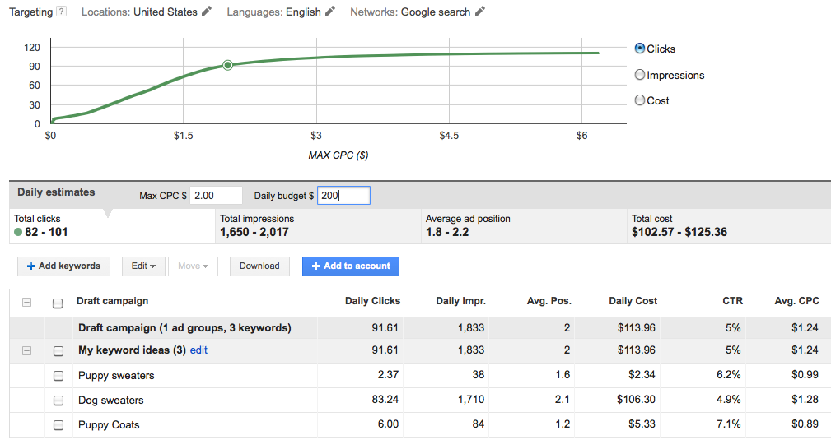
Then, you need to run with CPC for a while, until you have enough conversion data, before thinking about transitioning to another type of bidding. Here is a list from Google on best practices for the conversion optimizer. You need at least 15 conversions in a 30 day period to be eligible, but Google and I both recommend you collect as much as possible before enabling CPA or eCPC bidding. So, you’re going to want some good CPC management until you reach the point where you have lots of data.
Here is a great blog post that shows you how to analyze your bids based on average position using pivot tables. That’s a really great way of analyzing your bids. You can see which average position leads to the highest conversion volume within your ROAS or CPA limits. If you download your keyword report from a custom report in Analytics that includes revenue data or you have dynamic conversion tracking in AdWords that pulls real revenue data, you could actually figure the gross revenue per average position. Just add a sum for revenue and cost to your pivot table during the analysis outlined in the linked article, then do a calculated field for revenue minus cost.
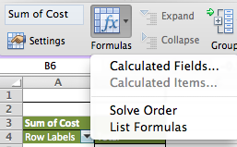
Then, you can adjust your bids appropriately. If you find an average position of 2.5-3.0 is best for conversion volume and gross revenue, then you’ll want to analyze your data to see what your avg. CPC is for that position, and adjust until you start seeing that you’re in that position range. Don’t forget to bookend your proposed changes. You’ll want to predict what the changes you’re making may do to your account.
Once you’ve got a decent amount of conversion data (the more, the better), you can consider experimenting with eCPC or CPA bidding. Sean wrote an article that does a great job of explaining the difference between target and max CPA, optimizing CPA campaign, and how to move away from CPA bidding if it doesn’t work out for you. I won’t go into detail that he already covered, so check that article out. Also, here is a step-by-step guide to setting up CPA bidding.
And I hate to feel like I’m copping out, but we have a great article about eCPC bidding as well. Basically, if you want more control than CPA bidding allows, but you want Google to be a bro and catch chances for more conversions that might be limited by your CPC, try out eCPC.Here is the Google guide on eCPC, which includes step-by-step instructions for setting it up.
Ways to manage bids
Most of you already know about the most common ways to manage bids: in the editor and in the interface. Both BingAds and AdWords allows for these types of changes. For any bid change on more than a couple of keywords, I’d recommend using Excel so you have record of the data and your changes as well as being able to bookend the results. AdWords does have a sweet, new bulk edit tool that allows you to raise all your CPCs to first page bid, by whatever % you’d like, etc. I’ve used it in a couple of instances, but you really should be a good account manager and download that stuff for the reasons I just stated. Then, you can upload your changes through the editor or through the UI.
But wait, there’s more! You’ve also got automated rules, scripts, and bid management software as viable bid management options!
- Automated Rules
I wrote an article about using automated rules to target optimal ad positions, so check that out. But in short, you can set up anything from simple to super complicated bidding rules to manage your bids. Raise bids by 5% once keywords with the label “best at avg. pos 2-2.5″ (you’ll need to filter by the label and then select the keywords) get below position 2.5. Raise bids on keywords that get conversions under your CPA goal and fall below position 3. Lower bids on keywords once they spend double your CPA goal without a conversion. There’s so much you can do!
To explore and set up rules, click the “automate” button in your keywords tab.
Check out all this STUFF:
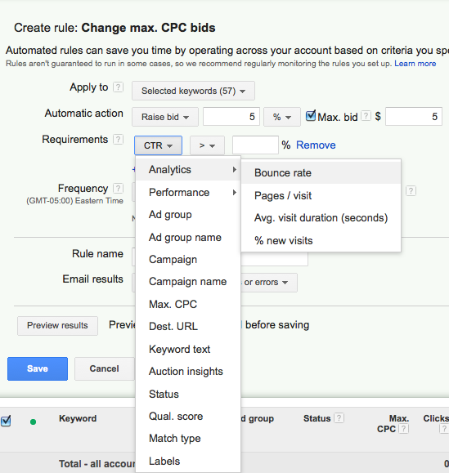
There are just so many ways you can set up automated rules for bid management. I could rattle off examples all day. But, remember, once you have them all set up–check the logs! You can go to the “bulk operations” tab in the left navigation to view all your logs. You can also set it up so you get an email with all the changes. You don’t want to set this stuff up and forget about it. Then you’ll have some issue pop up in your account and have no idea it’s because that rule you set up a month ago didn’t work in the way you’d hoped it would, and it’s been tanking your account slowly. Just ONE more thing about automated rules, because I really could nerd out about them all day: remember to pay attention to the frequency and the “using data from” section. Make sure you don’t do it too frequently and you use enough data to make sense!
- API Scripts
Here is an AdWords article about using scripts for automated changes. AdWords scripts let you automate stuff with JavaScript code. You can create, edit, or delete stuff. It’s pretty much totally customizable, and you’re really only limited by your creativity and JavaScript knowledge.
Scripts really work in a super similar way as automated rules, but instead of going through and setting up a hundred of automated rules, you can write code to do it. Sam made a great step-by-step video blog showing you how to use scripts and showing you some cool ones to use.
- Bid Management Software
There’s a lot of bid management software out there. Sam also wrote this article about how bid management software is the future of PPC. So, check that out. But basically, if you could save enough cash in terms of time saved and an increase in gross revenue due to an increase in bid management efficiency, then you should totally look into some bid management software. We use it on some of our accounts at Hanapin. Some of our clients are HUGE with SO MANY products and keywords. Getting a software to maximize ROAS and conversion volume in addition to quickly and easily creating suuuper slick looking reports is almost just necessary.

So, there you have it! So many ways to manage your bids. Which ways do you find most effective? What tips do you have?

