The Beginner’s Guide To Setting Up An AdWords Account
Are you interested in starting an AdWords PPC account but been a little hesitant to set it up on your own? Then PPC Hero’s Starting An AdWords Account From Scratch series is just what you’re looking for. In this month’s series, we will walk you through the basics of setting up an account, from keyword research all the way to activating your first campaigns. Before you get started though there are a few questions you should ask yourself to make sure you are ready to create your own AdWords account:
Do I have a website in place and is it appealing to users? AdWords ads do a great job of getting people to your site, but that’s as far as the ads can take them. In order to keep people on your site and get them to convert you have to have a website that is visually appealing and allows the searcher to easily find the information they are looking for. Make sure you have a good, quality website before setting up any PPC account.
Do I have a PPC Strategy in place? Before you even begin to set up an AdWords account you want to make sure you have a strategy and defined goals. Check out Amy’s article on how to develop your own PPC strategy.
Am I willing to commit to PPC advertising? We have seen clients have success on AdWords with budgets as little as $500 per month to over $100,000 per month. No matter what the amount of your budget, you have to be committed to making PPC an integral part of your marketing strategy in order for it to be a success. We suggest letting your account run for 3 months to begin truly seeing its potential.
If you’ve been able to answer yes to the three questions above, then you are ready to create your first AdWords account!

Creating An Initial PPC Keyword List
Keyword research is the foundation on which you build your PPC account. The stronger the keyword list, the stronger your account will be.
What are keywords? Keywords are the words or phrases your customers would use when searching for your product or service. When a customer types in a keyword you are bidding for they will be shown an ad.
I thought it would be helpful to walk you through an example using our company Hanapin Marketing and show you how we build an initial PPC keyword list.
Pull From The Company Website
The first place you should start looking for keywords is the company website. This is the best way to identify the core words and phrases that describe your business. Looking at the website layout will also help you see any keyword themes that may be present. Let’s take a look at website for Hanapin Marketing:
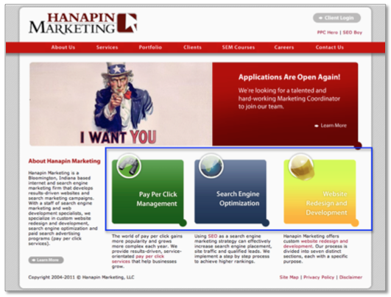
Right away you can see the three categories of services we offer:
- Pay Per Click Management
- Search Engine Optimization
- Website Redesign and Development
To help keep myself organized, I like to group my keywords by theme, in this case types of services offered, instead of just creating one long keyword list. Next, I’m going to click through to each individual service page and write down every relevant keyword I find on the site for each category. Here’s an example of some of the keywords I identified for Pay Per Click:
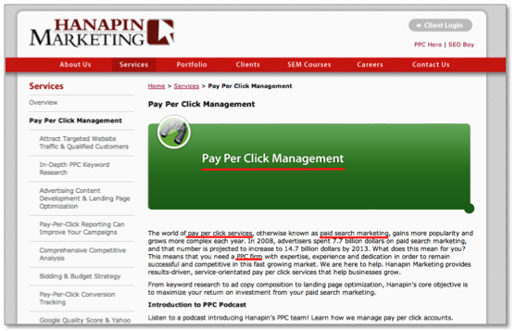
As you are going through your site, don’t forget to include branded terms when developing your keyword list. Branded keywords are extremely beneficial to any PPC account, as they tend to have higher conversion rates and lower cost per conversions. Below are the list of keywords I put into my excel spreadsheet from the website:
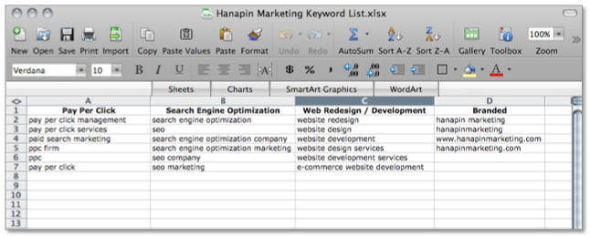
As we move through the rest of this example, we’re only going to focus on building out the keyword list for the Pay Per Click terms.

Include Synonyms and Keyword Variations
After you’ve pulled keywords from your website, look at your list and see if you can think of any synonyms or variations of those keywords. For example, pay per click is also known as paid search, so I’m going to substitute “paid search” for “pay per click” in my keyword list. Pay per click also has other variations. It is commonly abbreviated as “ppc” or is written to include hyphens “pay-per-click.” I want to target these keywords as well so I am going to substitute the variations in for the original keyword.
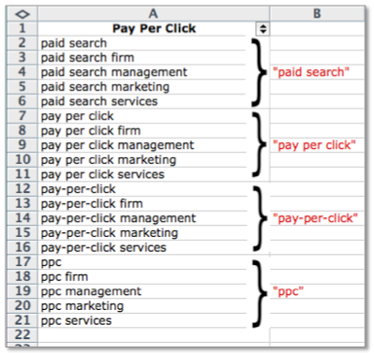

Think Like Your Customer
Now that you’ve spent time looking at the company website and thinking of other keyword variations, take a step back and put yourself in the customer’s shoes. What would someone who’s looking for your product or service type into the search engines?
Hanapin is targeting people who need management for their PPC accounts. However, if the person searching is inexperienced in the industry they might not use the term “pay per click” or “paid search”. They may search on more generic terms like “online advertising” or “internet marketing”.
Also think about the intent of your customer. If a person is looking for help with managing their account it’s likely that their current account is not performing well and wants to improve their account performance. Because of that “improve ppc account performance” is a longer-tail keyword we could also target.

Keyword Research Tools
Now that you’ve spent a lot of time brainstorming keywords, implement these keywords into a keyword research tool to uncover more keywords that fit your business. There are many great keyword tools out there, both free and paid, that will help you expand your PPC keyword list. I’m going to use the AdWords keyword tool since it’s free and one I use often, though I do recommend using a variety keyword tools to get different perspectives.
All you have to do is enter in a keyword and hit search, and Google will generate a list of related keyword ideas.
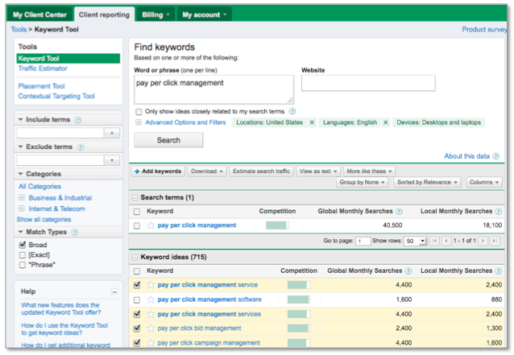
Go through the list and check the ones you think would fit into your account. You can see here I’ve selected four of the first five words, but left pay per click management software unchecked since we don’t offer that service. Once you’ve selected your keywords you can download them into an excel file and add them to your original keyword list.
Below are some of the additional keywords I found using the keyword tool.
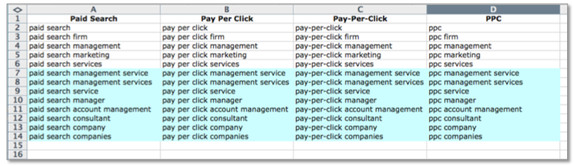
Notice that I’ve also expanded these new keywords to the other pay per click variations identified earlier. I’ve also broken down my original pay per click list into sub categories. I try to keep myself as organized as possible when creating keyword lists because it will make setting up your AdWords account a much easier process.

Tips For PPC Keyword List Creation
Here are 3 tips for creating your initial PPC keyword list:
- Start small. Once you start researching keywords it’s very easy to create a list of thousands upon thousands of keywords. It’s important to focus on the quality of keywords rather than the quantity. The best keywords are the ones that are relevant to your products or services and accurately reflect the content of your website. I recommend starting your PPC account with an initial list of a couple hundred keywords. Let these keywords run and then see where your PPC account has opportunities for growth.
- Don’t be too general. General keywords are going to have a lot of competition, which means a higher cost-per-click. For example, even though PPC is a form of advertising I wouldn’t bid on the keyword “advertising”. Unless you have a large PPC budget, stay away from very general keywords and focus on more specific keywords that better describe what you offer.
- Don’t be too specific. Although specific keywords tend to perform better than general keywords, being too specific can limit your ad exposure if very few people are searching for it. For example, I wouldn’t include “companies that can improve my ppc performance” but instead just include “improve ppc performance” which will pick up traffic from those longer-tail search queries.
Keyword research is an on-going process, but starting off with a strong list of initial keywords will start you on the path to PPC success.

Campaign Structure Basics & Best Practices
The most important thing to remember when developing your AdWords structure is that organization is key to making the most of your PPC account. Account structure and organization will affect your quality score and dictate how your account performs as a whole on the search engines. Now let’s get to it!

Choosing Your Campaigns and Ad Groups
There are many ways to create a useful account structure. Your campaigns should be segmented by higher-level ideas so that you can drill down into more tightly themed ad groups and keywords. Consider the following ways to segment your campaigns:
- Based on the products and services you offer
- Based on geographical location
- Based on performance and bidding
- Based on brand names vs. generic names
- Based on seasonality of your service or product
- Based on keyword match types (you can also segment this way on an ad group level too.)
Make sure that your ad groups follow suit and are relevant to the campaigns you have chosen. Having a campaign about handbags and associating ad groups focused on shoes and lip-gloss is not in your best interest. But setting up something along the lines of clutches, fanny packs and slings for your ad groups might perform better. The point is to make your campaigns, ad groups, keywords and ads all relevant to each other within your structure. Of course, reviewing your keyword research and lists will help you determine what kind of ad groups you will need and how you can silo those keywords for maximum performance.
It is a good rule of thumb to have around 3 to 5 ad groups per campaign so that they remain easily manageable. You can always create more concentrated campaigns and ad groups. For example, you could potentially have campaigns for each kind of handbag such as clutches, slings and fanny packs and break specific ad groups out from there. Do remember that the more concentrated and organized your structure is, the better your account will perform overall.

Campaign Settings
Once your campaigns and ad groups are configured with keywords, your next step is to make sure settings are correct. This is a very important step. Having the wrong settings in your campaigns will not completely ruin your account, but it can cause a PPC Manager to have one too many “Ah ha” and “Oops” moments.
Here are some of the top settings to make sure are set properly:
Locations and Languages
In what geographical locations do you want your ad to show? Also, are you planning to target people who speak different languages? You can change the setting here to reflect these options. Though available for the Search Network only, there are advanced location options that can be utilized for both targeting and exclusion methods.
Networks and Devices
Pretty much just what it sounds like –this section will allow you to pick where you would like your ads to show on the Internet.
- Search and Content Network –You have the choices of Google search, which is Google.com only, and the entire search network. This will include Google.com and all of their partner sites. For new advertisers, this is your best bet since it will get your ads out to the broadest network of viewers. The content network can be a little tricky to manage, so if you’re a PPC rookie, I highly suggest taking it slow with these options.
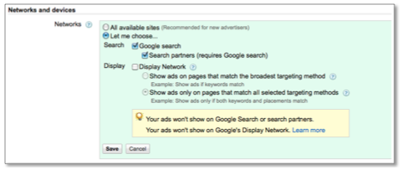
- Devices Setting – most advertisers choose “All” for this option. It allows you to show on desktop computers as well as laptops and mobile devices with full browser capability. This information can be segmented in AdWords and in time, you may choose to break out separate mobile campaigns.
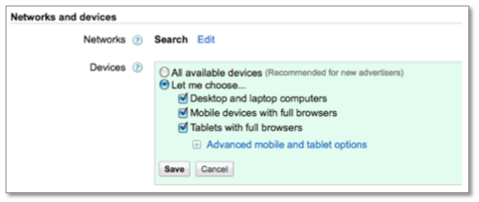
Bidding and Budget
Arguably, this is the most important setting. If you set your daily budgets too high, you can blow through your entire month’s budget like a hurricane. If you set the daily budget too low, your account runs the risk of not spending the entire monthly budget. Either way, you are not allowing your account to reach it’s full potential. Lurking quietly somewhere in the middle is the perfect daily budget.
The best way to determine this is to take your total budget, divide it by the number of days in the month and then split out that number amongst your campaigns. Once the account is running, you will have a better idea of how your campaigns are spending their budgets and can reallocate accordingly! It is always best to set your budgets at a level you can afford and are comfortable with.
As for bidding settings, the best way to start out is to Focus on Clicks and Manually bidding for clicks. This choice allows you to have more control over your money. Don’t be afraid to experiment with the other bidding options, eventually, but wait until your account gains the needed data to make these decisions.
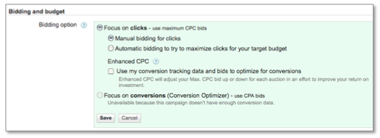
Advanced Settings
The ad delivery option is what you should worry about in this section. You can show your ads in a rotating fashion, which will allow Google to show them more evenly. This is the preferred method since it makes a/b testing for your ad copy easier and it also offers better control over your metrics. Other options include Optimizing for clicks (this is the default – change it!) and Optimizing for conversions.
This setting is not to be confused with the Delivery Method setting in the Bidding and Budget area. You do want to change the delivery method to Standard, which will show the ads evenly over time and not spend your budget all in one swoop!
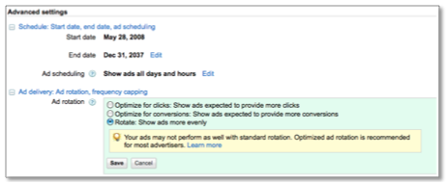
These are just the basics of getting started. There is a lot to learn, but don’t feel overwhelmed. Like any worthwhile shopping spree, running a PPC account is a never-ending process that takes patience, organization and a little luck when you first start out.

Ad Writing Tips For A New Account
Thorough keyword research and a tightly knit structure will be useless without great ads. You need to entice searchers to click on your ads, and once they land on your page, perform the desired conversion. Relevant ads and landing pages help you achieve a good cost per lead and ROI, however, there’s something even larger at play with great ad text; your Quality Score depends on it.
The AdWords system issues a keyword level Quality Score to each of your keywords (calculated according to your exact matches) and click-through rate is one of the biggest players in the calculation. A high Quality Score ultimately helps you achieve a higher position on the page and lower overall cost per clicks, which means your budget can stretch a bit further for the same amount of clicks.

Rules of an AdWords Ad
You have 130 visible characters (headline, description, and display URL) to encourage a user click on your ad – that’s less than a Tweet. The best way I’ve found to write ads correctly the first time is to open up Excel, and use the LEN function to count the characters in each of your lines.

Character Limits
- Headline: 25
- Description Line 1: 35
- Description Line 2: 35
- Display URL: 35
- Destination URL: 1024
Try to use as much of your allotted characters as possible and add in punctuation where necessary. In the past, it wasn’t always necessary to add a period for the end of description line 1, because the way AdWords displayed it still made sense. Today, you’ll want to make sure that your ads have some sort of punctuation at the end of the first line whether it’s a dash, period, or a comma.
In February of 2011, Google started promoting eligible ad’s first description line to the headline. To qualify for this style, an ad needs to be above the search results and end with appropriate punctuation. For the most part, these ads look normal, just with longer headlines, but you really need to check your ads after upload to make sure that they look nice. For instance, after this change was made, ads that were missing punctuation in line 1 could end up a bit awkward to read in the longer headline version.
The example below shows a traditional AdWords ad where the missing punctuation isn’t very difficult to read. The longer headline ad on the bottom, however, makes no sense. Ads that don’t make sense (even in a top position) are more likely to receive less user attention, and all your hard work will be spoiled.
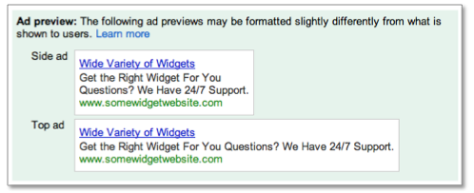
You might also notice that your ads are displayed with the Display URL in the headline. Google started doing this in May to achieve even higher click-through rates for advertisers in position 1. The domain URL in the ad headline combined with promotion of description line 1 to the headline might mean you’ll receive impressions where your ad’s headline, description line 1, and Display URL are all in the headline spot with a count of up to 68 characters.

Know Your Brand, Products and Audience
Before you dive head first into ad writing, take a step back and think about the brand andproducts you’re promoting and the audience you want to appeal to. There are a lot of aspects surrounding a company that should help you in writing your ad text.
- Brand: If marketing classes in college taught us anything, it was the SWOT analysis. The company’s SWOT (strengths, weaknesses, opportunities and threats) should help you develop some key areas to call out in your ad text. You can borrow from other marketing areas and the landing pages to keep the message consistent.
- Products: What do you sell/provide? What does it cost? The language you use in your ad text needs to be appropriate for the actual product you’re promoting. Your ad text should encourage those likely to buy to click the ad, and simultaneously filter those who aren’t serious.
- Audience: Have a sample, imaginary customer in your mind. What does he or she want to accomplish? Value? Does he or she already know about your brand or are they shopping around?

Writing Effective Ad Text
Below are five elements to writing effective PPC ad text.
- Attention grabbing title: Take a look at the Google SERP example below. There are potentially a ton of ads in that space depending on the search. You’re competing against the first three ads in the lovely colored box at the top of the page, ads with +1, ads with highlighted keywords, ads with extensions…etc. If you want to be competitive, you’ve got to make yourself stand out! Just make sure it’s appropriate for your brand, product, and audience.
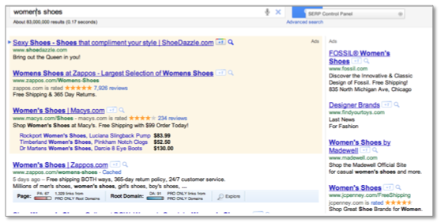
- Call to Action: Your call to action tells the customer what you want them to do. If your conversion goal is a sale, tell them! You can use phrases like ‘Buy Today’ or ‘Shop Now!’ This also helps to filter people who aren’t ready to buy, but are still shopping around. If your landing page contains information about a nursing school with a lead form, encourage users to ‘Signup For More Info!’ Whatever it is you want people to do, make sure you’re using an appropriate call to action.
- Keywords: You want to include a keyword in the ad. Typically, including the keyword in the ad title and description increases your relevancy and helps your Quality Score at the same time (improved keyword score and click-through rate). When you do this, just make sure the rest of your ad is written for the user. Which brings me to the next point – benefit driven text.
- Benefit Driven: What does your product/service offer? What will your customers receive? What does your product offer that the competition does not? This is where some detective work comes in handy. Keep an eye on the competition and what they’re advertising in their ads. Benefits can include discounts, sales, free shipping, 24/7 support, etc. Make sure it’s included!
- Landing Page: The landing page design is an entirely different beast, and we have a lot of resources dedicated to this topic. What it comes down to is are your customers reaching a landing page where the conversion is obvious? Are they finding what was promised to them in your ad text? If your landing page is bad, you’re less likely to receive the conversion.

Ad Settings
Last, but not least, are the ad settings. We’ve given you a rundown of the campaign setting options in AdWords, but we’ll recap the ones vital to how your ads will work.
- Delivery Method: You can choose how quickly your ads are shown everyday though either the standard or accelerated delivery budget method. Basically, if you have a campaign that is limited by its daily budget everyday (Google will tell you if a campaign budget is limited in the interface under status) you’ll likely want to choose a standard delivery so the system will space out your ads throughout the day and not run out of budget early. Accelerated is better for campaigns that aren’t meeting their budget. This tells the system to show your ads as quickly as possible.
- Ad Rotation: With this setting, you can choose rotate, optimize for clicks, or optimize for conversions. When you introduce new ads to your campaign (like during setup) you’ll want to keep this setting on rotate so that each of the ads you’re testing gets an opportunity to show and you can see which ones actually do better. After ads have been running for a while, you can change to one of the optimize settings so that the better performing ads will show more often.
- Ad Scheduling: You’ll want to allow the system to accumulate enough data before you start implementing ad scheduling. From the dimensions tab in AdWords, you can run an hourly or daily report for each campaign and identify areas where you spend a lot with no conversion. Then you can decide to either bid less/more during certain hours based on their success or even turn bidding off entirely for poor performing days. I would typically recommend bidding less rather than turning it off completely.
Frequency capping: This setting is only available for the Display Network. Essentially, you can limit the number of times your ad is shown to the same user per day, week or month for an ad, ad group, or entire campaign

Getting Your AdWords Account Up and Running
You are almost at the end of the Yellow Brick Road and will soon be able to see the Great Oz of Google… You’ve gathered your keywords list from the Scarecrow (the brains of this operation for sure!), your account structure is set up from the Tin Man (I really do have a heart!) and you have all your ads written with the help of the Cowardly Lion. Last steps are to activate your account and track your leads!

Signing Up For An Account
Google takes you through four steps to set up your account. Since you have your research done and all of your settings are ready, this will be fairly simple.
- Step One: Target your Customers (check!)
- Step Two: Create your Ads (check!)
- Step Three: Set your Pricing (check!)
- Step Four: Sign up (and here we are…)
Once you have completed the first 3 steps and reviewed your entries, you will be able to enter your Google account email address and password. There are two options here – you can sign up with an existing Google account or you can create a new one. It just depends on your preference. Our suggestion is to set up another email account specifically for AdWords. This way, if there are additional people working in the account, they won’t have access to your personal email.
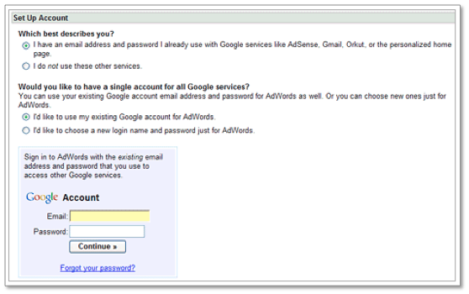
If you are creating a new account, a screen like this will be revealed:
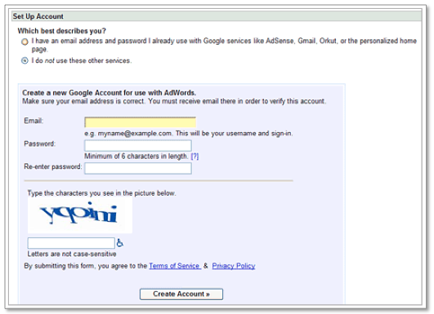
You will be asked to go through a couple of checks and balances, like verifying your email address. After that, there are only a couple more steps and we promise you will be set!

Payment Options
There are two ways that you can set up billing with Google for your shiny new AdWords account.
- Postpay payment method – with this option, payments are made only after you accrue advertising costs. You are billed 30 days after your last payment or when you account reaches its billing threshold. A credit or debit card can be entered for payment and your ads will typically be shown immediately after authorization. You can also opt to have your billing drafted from your bank account. A draft may take a bit longer to approve and thus hold up your account from starting immediately.
- Prepay method – you pay for your advertising in advance of receiving any impressions or clicks. Google will notify you when your funds are running low and will allow you to replenish the money at any time. Again, you can use a credit or debit card as well as draft the funds from your bank. Same time frames apply for your ads showing as the postpay method.

Tracking Your Performance
The final step to setting up your AdWords is to place your conversion tracking codes. Conversion tracking is when a cookie is placed on the user’s computer and a correct match is made, then Google credits your account with a successful conversion. A conversion is designated as a purchase, sign-up, page view or lead. To view your successful conversions in AdWords, click your Campaigns tab or click on the Reporting and Tools tab and select “Conversions.”
Here are the steps to generating and placing your conversion code snippet:
- Click on the Reporting and Tools tab > Conversions
- The code is provided at the bottom of the screen. There are no system requirements for this code to be placed on your site. In order for Google to track these conversions properly, the searchers must be able to download images as well as have cookies enabled on their computers.
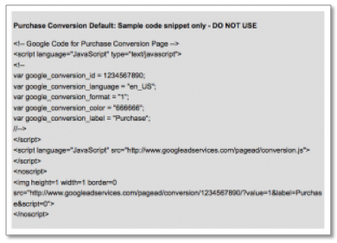
- Now you can copy and paste the conversion code into the associated conversion pages of your web site. The code snippet should be placed between the <body> tags and NOT in the header or the footer of your code.
You are in! Now, the journey does not end here… there is so much more you can do with your account. It’s time for optimizations, experiments, mobile campaigns, display network campaigns – the list goes on and PPC Hero is here for you. We will help you through all of it. So, just click your heels and gather that data. Remember, there’s no place like Google…

