The Complete PPC Account Audit Guide
Your PPC account is not perfect. We hope you aren’t surprised we said that. The truth of the matter is this: no matter how hard you work on building an account and optimizing it according to best practices, you could miss something. An even truer statement is that the longer you work in an account, the easier it is for things to slip past your ever-watchful eye.
In these situations and on occasion, even if your account is performing well, you need to take the time to audit your efforts.
What is an account audit?
An account audit is quite simply a dive into your account to determine areas that could use further attention or work in order to improve performance. We’ll outline the actual process of the audit shortly.
When & why you should audit
There’s really never a bad time to audit your account because typically speaking, you’re going to find something to help improve performance through this process. However, you don’t particularly want to audit your account after a recent strategy change or account update, as you could be auditing based on skewed information.
You want to audit your account, of course, if you’re having performance issues, but as mentioned earlier, it may also be a good idea to audit the account after the same person or team has been managing it for an extended period of time.
Who should perform the audit?
This is a tricky question, because it really depends. If you’re auditing a particular issue in your account then you could keep the task yourself and dig directly in to the areas of your account that could be contributing to the problem.
However, if you’re talking about a more comprehensive check, it may be better to outsource the project and get fresh eyes on things. No matter how much you try to deny it, as an account manager you have a slight inability to look at something you uploaded and thought would work and say “Nope, not working, have to stop it.” And as we’ve already mentioned a couple times, it’s very easy to look over the “basics” and assume you have things set up correctly or just skip stuff because there’s no way you’d set your campaign to target the Search and Display networks, right? (A little fun sarcasm never hurts!)
Where should you be looking?
Let’s get to the meat and potatoes of this guide, shall we? The following checklist outlines all the different account areas you can dive in to during an account audit and what kinds of things to look for:
- The Basics
  - Date Range
    - First things first, you need to make sure you’re looking at a long enough range of time to analyze relevant data. It doesn’t really do you any good at all to look at 30 days worth of conversion data and to make changes based on that information because odds are that data isn’t statistically relevant enough. At the very least, we like to look at at least 3 months worth of data if we’re diagnosing a specific issue and a year’s worth of data is preferable when doing a general audit.
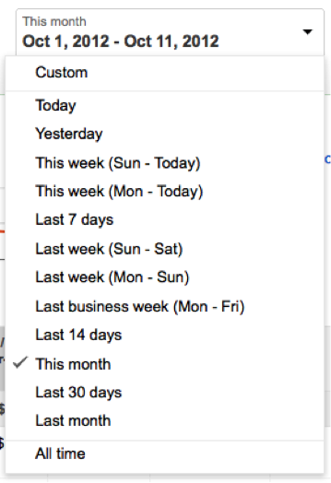
- KPI’s
  - The diagnosis means nothing unless you know what the most important metrics are. If it were an account you’re managing, we would imagine you have these KPI’s picked out already. It may be worth a quick check with your client to make sure you’re focusing correctly. Also, if you’re helping out a fellow account manager with an audit on an account you don’t typically look at, most definitely determine the key metrics to dive in to.
- Settings
  - This is usually one of our favorite areas of an account to audit, because specificsettings tend to be something that are set up when a campaign is started and then rarely revisited. A big win in this area is if a campaign is targeting Search and Displaytraffic within one campaign, which we actually find more often than you might guess. From here you can also check out device targeting (is mobile split out?), ad delivery method, ad rotation (optimizing for clicks when goals are based around conversions?), location/language targeting, and ad scheduling.
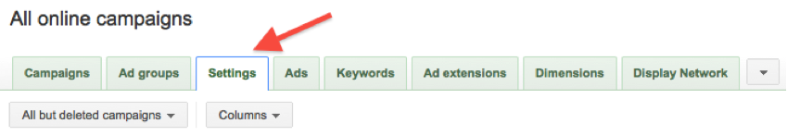
- Account Structure
  - Campaigns
    - The first thing to look at with campaigns is whether the naming structure makes sense and is easily understandable. Essentially, are the campaigns numbered 1-20 or do they have unique names that explain what kind of ad groups I’m going to find? As we talked about a bit before, are the campaigns opted in to the Search or Display network only? Are Interest Category or Topics campaigns broken out in to their own campaigns or folded in to a general Display campaign? Truthfully, checking out the campaign structure is where we start to determine if the rest of the account structure is going to follow a sensible method or if the remainder of the audit is going to require some Sherlock Holmes-style decoding on our part.
  - Ad Groups
    - Assuming the campaign structure is laid out in a regimented way, the next thing to look at is how the ad groups are set up. For instance, if you’ve got general product categories as your campaigns, are the ad groups the subcategories for the main category? Does each ad group have a maximum of 20 keywords in it? You want to make sure you don’t have an ad group that’s too wide reaching, as it will make ad copy writing to match the terms very difficult.
- Keywords
  - When auditing keywords, you want to check out how many broad vs. exact vs. phrase match terms are being utilized. If the majority of the terms are broad match, some expansion for increased ROI could be completed by adding phrase and exact match terms. If the account is relying predominantly on broad match, is there a logicalnegative keyword strategy in place to weed out irrelevant traffic? Further, has modified broad match been implemented? Are bids set too high or low to produce results or maintain goals? Finally, we like to take a look at a search term report and see if some keywords that bring a lot of traffic or conversions to the account still need to be added to the account structure to increase profitable reach.
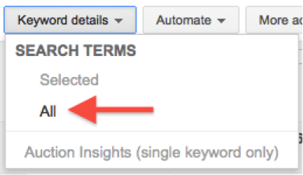
- Ads
  - When looking at ads in any given account, keep the basics in mind at the front end. Are the ads grammatically correct or do they contain spelling errors? Are the ads taking advantage of the punctuation that is permitted by the engines (i.e. do they contain any exclamation points, registered/trademark symbols, etc.)? Are the ads promoting prices or offers that have expired? Is there a different message being illustrated depending on the stage of the buying cycle this ad is intended for? Finally, when was the last time anad test was performed? Generally speaking if there isn’t always an active ad test in an account, we try to determine why. No ad copy is perfect so something should always be tested to further enhance performance.
- Quality Score
  - When it comes to Quality Score, you have to realize what you may uncover here could take some time to correct. So unlike settings or some structure issues, there isn’t asingle way to begin correcting course. The most important part of this portion of the audit is to pull a few key reports and analyze them. The team at PPC Hero adamantly stands by using pivot tables to dig in to determining your Quality Score picture on an average position level. Be sure you save all this work and reporting (not that you shouldn’t be doing that with everything) so you can come back in a few weeks or a month after making Quality Score relevant changes and compare your progress.
- Extensions
  - Ad extensions are an important feature of the Google interface, however they may not all be relevant to every vertical or business. Consider the account you’re looking at when auditing extensions and whether the extension would, in fact, bring anything to the table. Sitelinks are fairly usable in all verticals, so check to see if those are implemented. If so, do they lead the searchers to more relevant information to the original product/service? Is there a brick and mortar location for the business? If there is, check if location extensions (preferably through Google Places) are in use. Is the account running call extensions? Do they have the call extensions turned on only during call center/office hours? Have call metrics been regularly analyzed along with the rest of the account? If this is an ecommerce site, are product listing ads enabled via Google Product? Ad extensions are known to increase click-through rates exponentially, so they are an important aspect of the account audit to pay attention to.
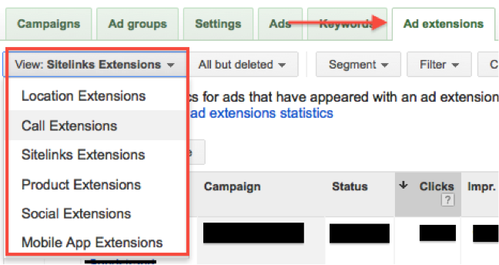
- Networks
  - Hopefully back in the settings section, you already checked to see if individual campaigns were opted in to either the Search or Display networks (not both at the same time). Now then, focus in on the Display network segments. Are all placements running automatically or are some in the managed placements section? Are the managed placements hitting goals? Are there any auto placements that can/should be moved to managed? Are ill-performing placements being excluded? Have Interest Category and/or Topics-targeted campaigns running? Are there additional campaigns of this kind available? Is the account running image and text ads for Display? Are the image ads of varying sizes to fit many placement types?
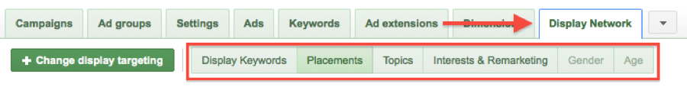
- Remarketing
  - First things first…are remarketing campaigns implemented? If there are, go to the shared library section of the account and take a look at the audiences that are set up for remarketing. Are they all collecting members? Is there an audience set up for each abandonment level? Can you find the cookie codes in the website code? Have all the cookies been set up with lengths that make sense?
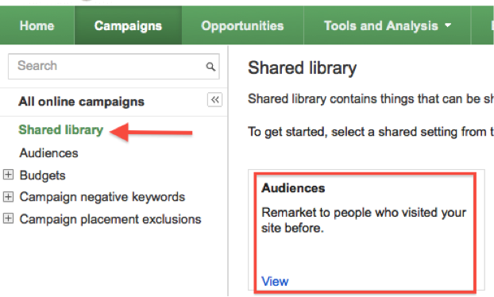

- Analytics
  - Not all accounts will have Analytics. Yes, this sounds crazy, but you first need to determine if there is an Analytics account (Google or otherwise) and if not…why not. Get one. It’s more than worth it. If there is an account, make sure it’s accurately attached to the paid search account. Has tracking code been placed on the website (ecommerce enabled, if applicable)? Are conversions or goals set up? Does the conversion data in Analytics match the engine interface? How are metrics performing (bounce rate, time on site, etc.)? Pull a site search report and see if there are new keyword opportunities to add to the paid search account. Have you looked throughmulti-channel funnels for any insights?
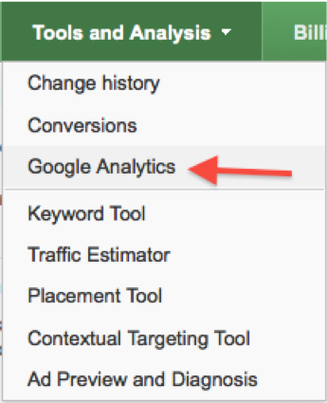

What happens after the audit?
Throughout your account audit, you likely compiled a list of things that need attention within your account. The first thing you must do is prioritize your list. There are a few different ways to handle the priority piece depending on why you did the audit in the first place. If you had a specific issue, you want to implement what will begin righting the ship the fastest first, then move to the things you may have uncovered along the way that aren’t directly related to the problem.
Assuming you completed the audit for a more overall look into what might be a bit out of whack, then you should prioritize according to what’s going to affect your bottom line the most, or according to the amount of time it will take to complete the particular tasks. You also want to make sure you don’t make too many changes too quickly, as you may do more harm than good. For example, when negotiating a restructure of ad groups or overall campaigns, you want to not move too much too fast or you may shock your performance history and end up making things worse.

